# CS 255 System Design Document Template

This template lays out all the different sections that you need to complete for Project Two. Each section has guidance to prompt your thinking. You will need to continually reference the interview transcript as you work to make sure that you are addressing your client’s needs. There is no required length for the final document. Instead the goal is to complete each section based on what your client’s needs are. Remove this note when you are finished, and replace all bracketed text with the relevant information.

## UML Diagrams

### UML Use Case Diagram

*[In Module Six, you were asked to complete a use case diagram based on your system design. If you would like to make any adjustments to your diagram, please do so. Please insert your use case diagram here. Check to make sure that you included appropriate components and symbols and that your design meets the client’s needs.]*

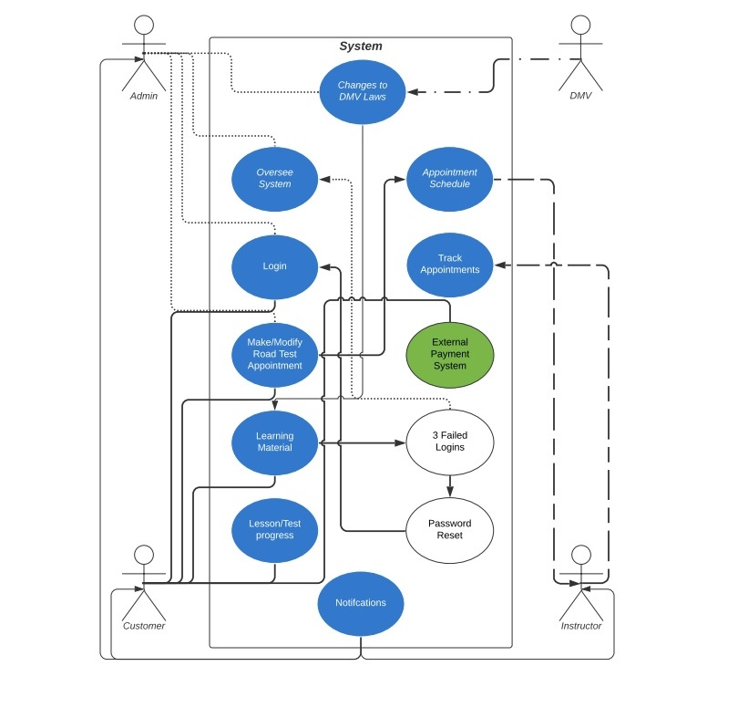

### UML Activity Diagrams

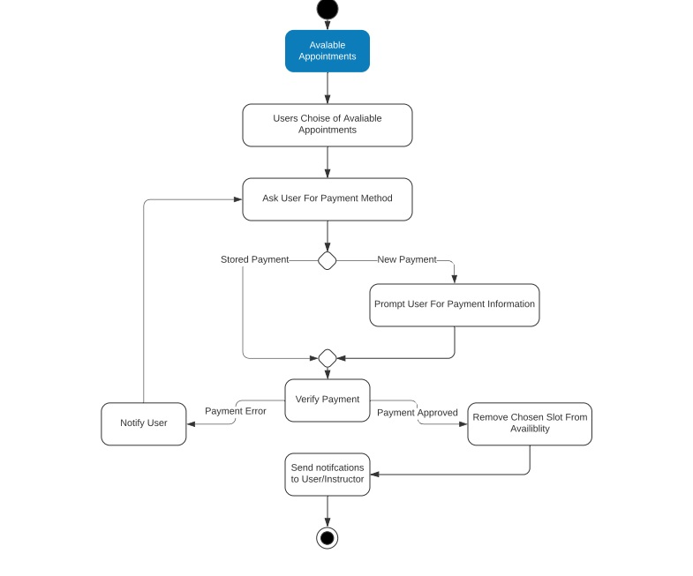

### UML Sequence Diagram

*[You were asked to create a sequence diagram based on* ***one*** *of the use cases you chose. Please insert your sequence diagram here. Check to make sure that you included appropriate components and symbols and that your design meets the client’s needs.]*

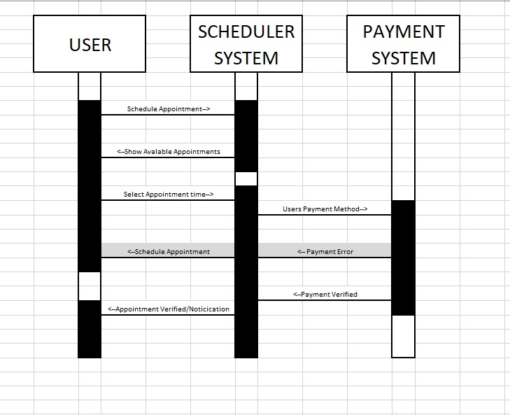

### UML Class Diagram

*[You were asked to create a class diagram based on the different classes and attributes needed for your system design. You are* ***not*** *required to include methods, but you may if you wish. Please insert your class diagram here. Check to make sure that you included appropriate components and symbols and that your design meets the client’s requirements.]*

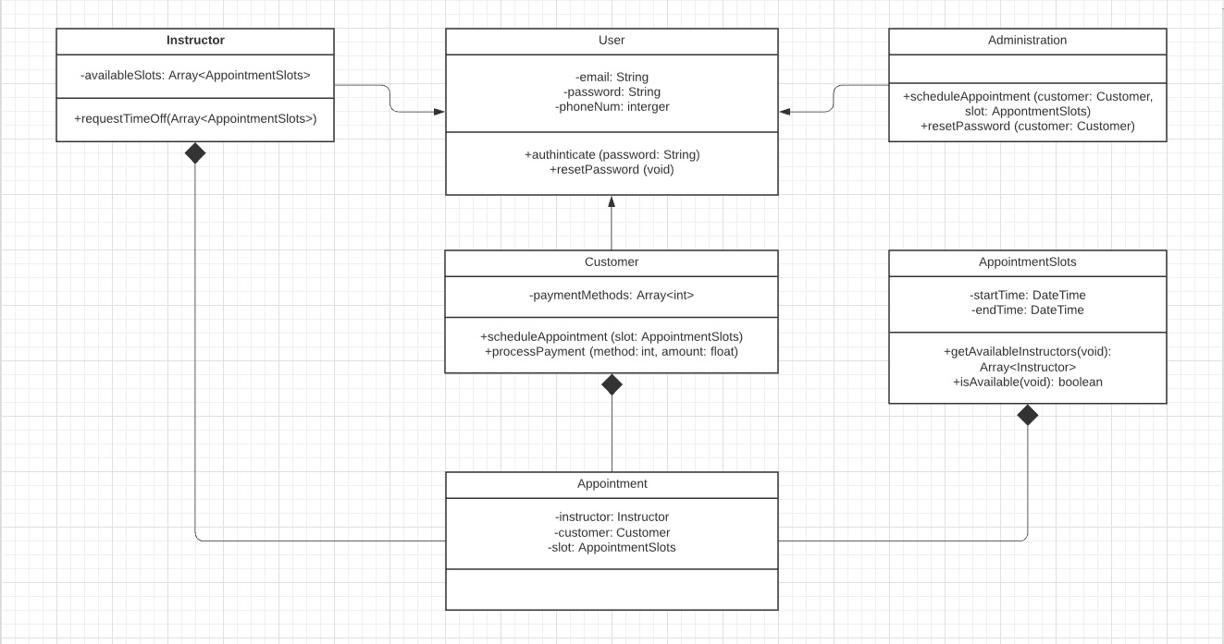

## Technical Requirements

*[Based on the diagrams you have created, describe the technical requirements of your system. These requirements should address the required hardware, software, tools, and infrastructure necessary for your system design.]*

*• The system will verify and validate user credentials when logging in.*

*• The system will allow a reset of a password after security questions are answered correctly.*

*• The system will be updated with any new regulation or laws.*

*• The system will have documents and information updates between platforms.*

*• The system will allow information to be modified and shared between platform.*

*• The system will track the progress of the class and hours the user logged.*

*• The system will show and track online test progress.*

*• The system will display user information and notifications.*

*• The system will downloadable for off line use.*

*• The system will have a scheduling system for scheduling the driving instructor reservations.*

*• The system should be compatible with Web-Browsers. (Edge, Safari, Chrome)*

*• The system should be compatible with Mobile Platforms. (iOS, Android)*

*• The system should be compatible with PC based OS’s (Windows, Mac)*

*• Product updates need to happen as new regulations/laws that effect the drivers are enacted.*